**Assignment: 2**

**Experiments**

1. **WAP add to numbers.**

**Coding:**

num1= int(input("type a number: "))  
num2= int(input("type another number: "))  
sum=num1+num2  
print('Sum of number',sum)

**Output:**

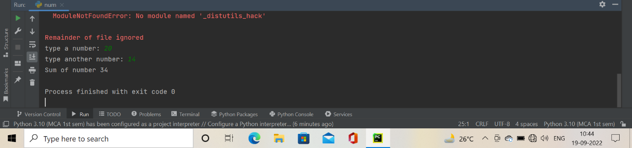

1. **WAP maximum of 2 numbers.**

**Coding:**

a= int(input("type a number: "))  
b= int(input("type a another number: "))  
print(a if a>b else b)

**Output:**

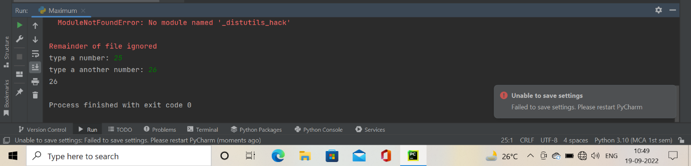

1. **WAP find factorial of a number.**

**Coding:**

num=int(input("enter a number: "))  
fact=1  
if num <0:  
 print("sorry. factorial does not exist for -ve number")  
elif num==0:  
 print("the factorial of 0 is 1 ")  
else:  
 for i in range(1,num+1):  
 fact=fact*i  
 print("the factorial of ", num,"is",fact)

**Output:**

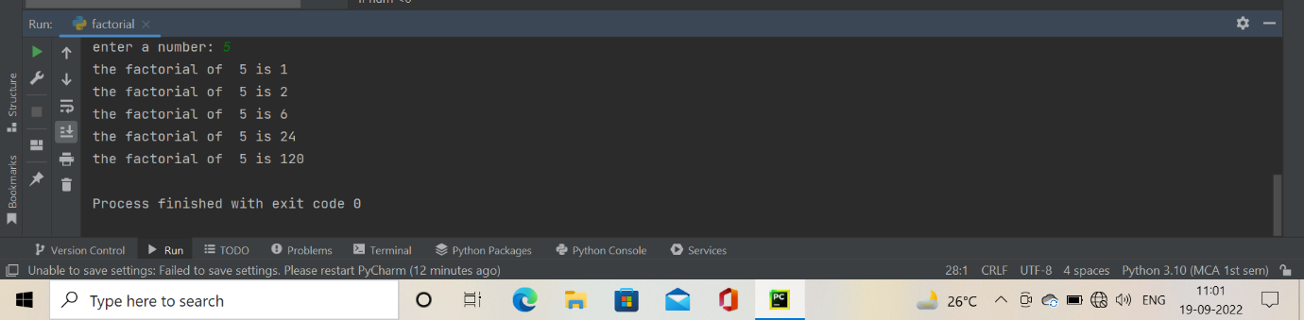

1. **WAP find simple interest.**

**Coding:**

p=int(input("the principal"))  
t=int(input("the time period"))  
r=int(input("the rate of interest"))  
si=(p*t*r)/100  
print('the simple interest is ',si)

**Output:**

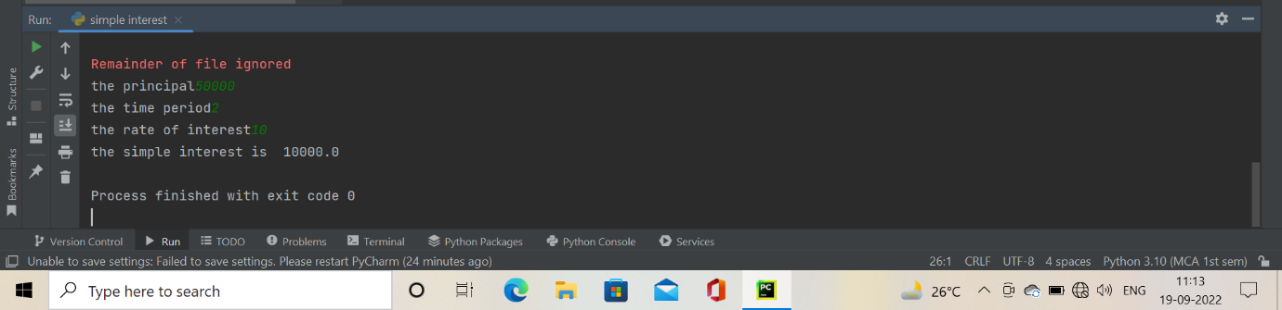

1. **WAP find prime number set.**

**Coding:**

a=int(input("enter a number: "))  
b=int(input("enter another number: "))  
print("prime number between",a,b)  
for num in range (a,b+1):  
 if num>1:  
 for i in range (2,num):  
 if (num%i==0):  
 break  
 else:  
 print(num)  
 break

**Output:**

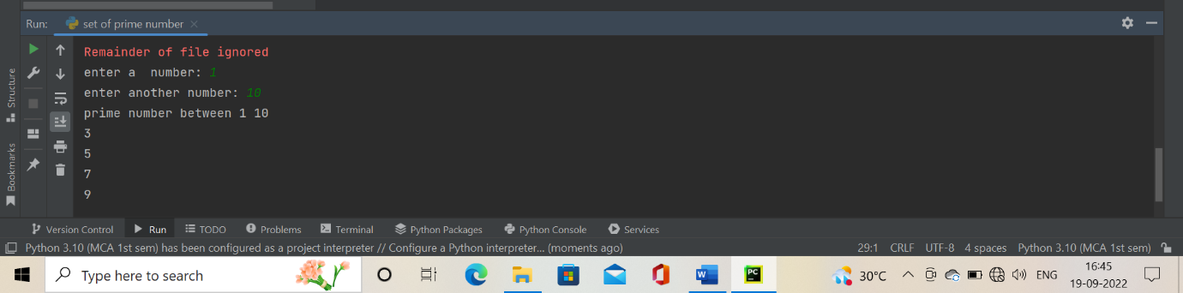

1. **WAP to check if a number is prime or not.**

**Coding:**

num=int(input("enter a number:"))  
flag = False  
if num>1:  
 for i in range(2,num):  
 if (num%i==0):  
 flag= True  
 break  
 if flag:  
 print(num,"is not a prime number")  
 else:  
 print(num,"is a prime number")

**Output:**

